**Concurrency Control**

* Transactions
* Locks
* Concurrent processing

**Scenario**

* You’re about to buy a new hoodie at the Campus Store with your ONE card
* Here is what three records in the database might look like before you make your purchase at the checkout counter
* How many database operations are involved in this case?

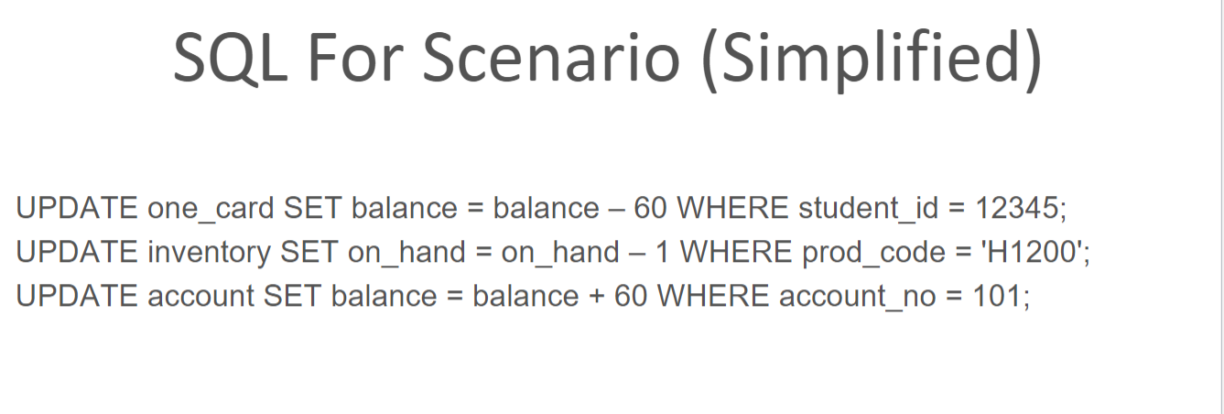

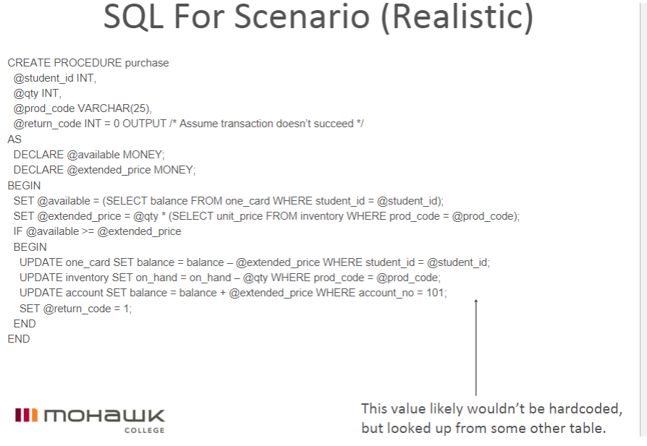

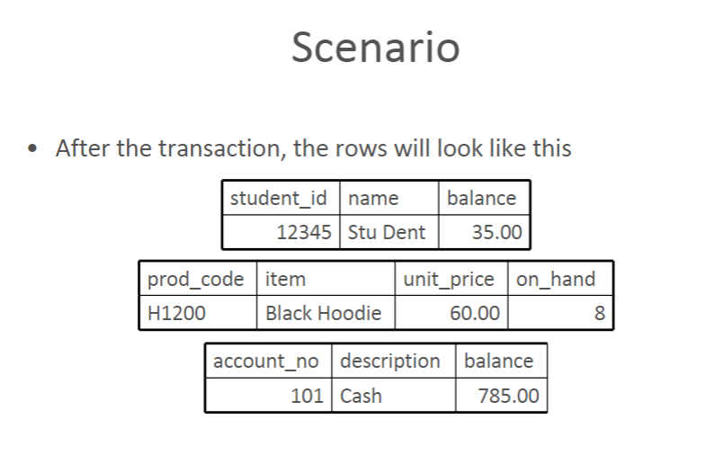

**Transactions**

* Definition: A logical unit of work that must be completed in its entirety or be aborted
* A transaction is created every time you read from and/or write to a database
* Many transactions consist of two or more database requests
* A transaction that changes the contents of the database must alter the database from one consistent state to another
* A consistent database state is one in which all integrity constraints are satisfied

**Transaction Properties**

* All transactions must adhere to the ACID rules
  + Atomicity
  + Consistency
  + Isolation
  + Durability

**Atomicity**

* Either the effects of all or none of its operations remain when a transaction is completed (committed or aborted respectively)
* In other words, to the outside world a committed transaction appears to be indivisible, atomic
* A transaction is a unit of work that appears as if it is either performed in its entirety, or not performed at all ("all or nothing" semantics)
* How does this property apply to our scenario?
* One Card, Inventory and Account must be successfully updated, otherwise changes are not made

**Consistency**

* Every transaction must leave the database in a consistent state, i.e., maintain the predetermined integrity rules of the database
* All constraints (Entity, Domain and Referential Integrity) must be satisfied with each update
* A transaction must transform a database from one consistent state to another consistent state

**Isolation**

* Transactions cannot interfere with each other
* The effects of an incomplete transaction are not visible to another transaction
  + A lock guarantees exclusive use of a data item to a current transaction
* Providing isolation is the main goal of concurrency control

**Durability**

* Effects of successful (committed) transactions must persist through crashes or system failure
* Typically by recording the transaction's effects and its commit event in a non-volatile memory (disk)

**Transaction Management**

* ANSI standard to govern database transactions supported by SQL commands BEGIN TRANSACTION, COMMIT and ROLLBACK
* BEGIN TRANSACTION starts the transaction
* COMMIT completes the transaction
* COMMIT is the default behavior
* ROLLBACK aborts all changes, returning the database to its previous consistent state
* Transaction logs are used to keep track of all transactions that update the database in case of ROLLBACK, abend or system failure

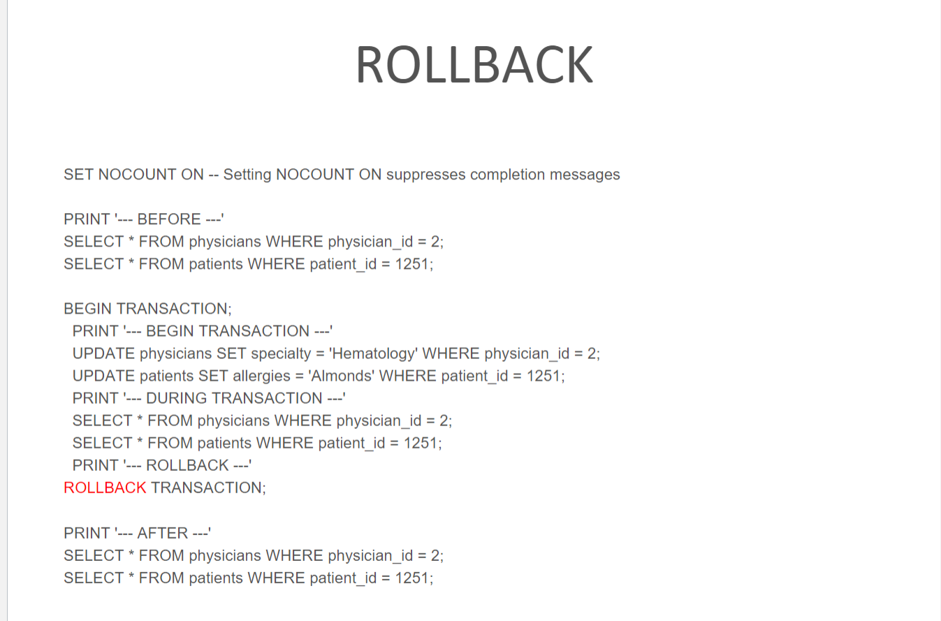

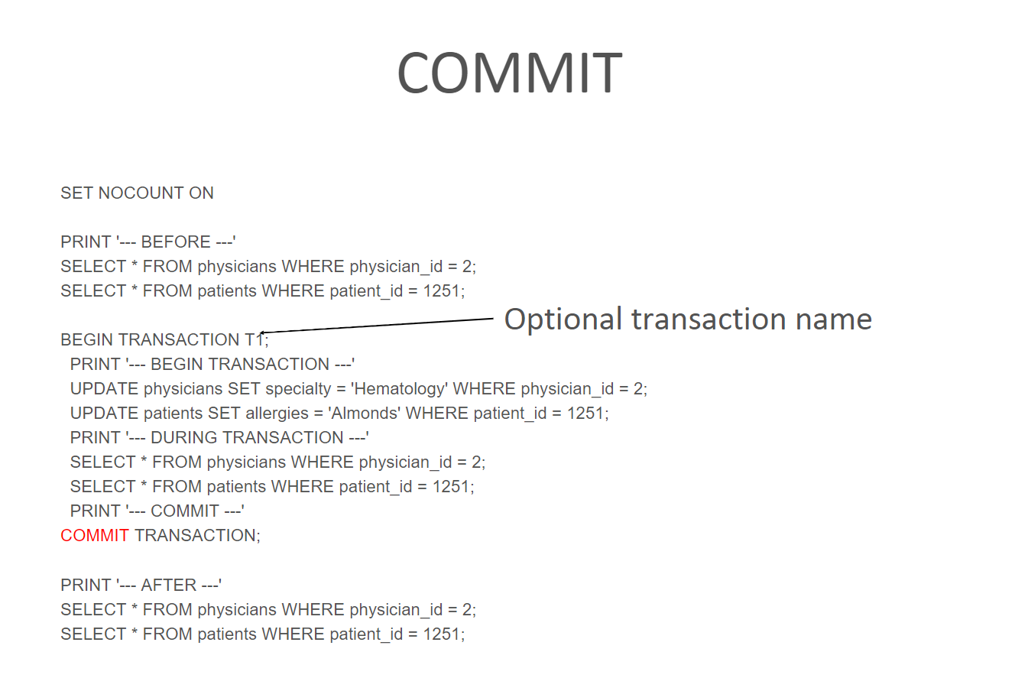

**Concurrent Processing**

* The co-ordination of simultaneous execution of transactions in a multi-processing database system
* To ensure serializability of transactions
  + Execution of transactions in the correct sequence
* Need to avoid data integrity and consistency problems
  + Lost update
    - one record simultaneously updated by two different users
  + Uncommitted data
    - Two concurrent transactions, the first is rolled back after the second has accessed the uncommitted data, violating isolation property
  + Inconsistent retrievals
    - One transaction is executing calculations on a set of data while a second transaction is updating the same data

**Locks**

* Guarantee exclusive use of a data item to a current transaction
* Released when transaction is committed
* Managed by a lock manager

**Lock levels:**

* Database
* Table
* Page
* Row
* Field

**Two Phase Locking Protocol (2PL)**

* Defines how transactions acquire and release locks
* Guarantees serializability
* Does not prevent deadlocks
* Two phases
  + Growing phase: a transaction acquires all required locks, without unlocking any data, until lock point
  + Shrinking phase: a transaction releases all locks and cannot obtain any new lock

Two Phase Locking Protocol (2PL)

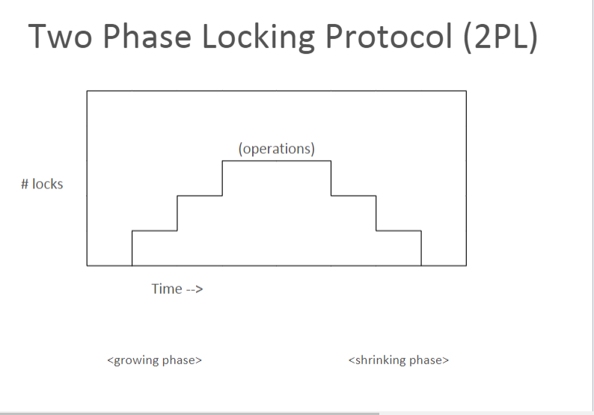

* **Rules**
  + Two transactions cannot have conflicting locks
  + No unlock operation can precede a lock operation in the same transaction
  + No data is affected until all locks have been obtained

**Lock Modes**

* Shared lock
  + One user asks to read a record
  + Other users may read it
  + No user can update it
* Update lock
  + Temporary state before Exclusive lock

•

* Exclusive lock
  + One user asks to modify a record
  + No other user can read it or modify it

Which SQL statement results in a shared lock?

Why bother locking a record being read?

Why is an exclusive lock necessary?

Why prevent users from reading the record?

**Deadlock AKA “The Deadly Embrace”**

* Occurs when two transactions wait for each other to unlock data
  + T1 obtains a lock on X
  + T2 obtains a lock on Y
  + T1 requests a lock on Y
  + T2 requests a lock on X
* Only exists with exclusive locks

**Deadlock Control**

* Detection
  + If a deadlock is found, one transaction is aborted (rolled back) and rescheduled while the other continues
* Avoidance
  + Obtain all locks, in succession, before executing
  + increase action response times
* Recommendations:
  + Low probability: detection
  + High probability: prevention
  + Use avoidance where response time is a low priority1
* Prevention
  + Transaction is aborted and rescheduled if possibility of deadlock exists

**Database Recovery Management**

* The database failing for unexpected reasons occurs occasionally
* Possible causes are power or hardware failure
* Recovery restores the database from a given state, usually inconsistent, to a previously consistent state
* Techniques used based on atomic transaction property

**Recovery in SQL Server**

* As each modification to the database, it goes to the transaction log first, it will be written to the database at a later time
* Log records for data modifications record either the logical operation performed or they record the before and after images of the modified data
  + The before image is a copy of the data before the operation is performed; the after image is a copy of the data after the operation has been performed
* In the event of a crash, the Database Administrator restores the database from the latest backup and then applies the transaction log